iConnect job dispatch client installation

vmsGUI.msi only for HSKP PC for room status
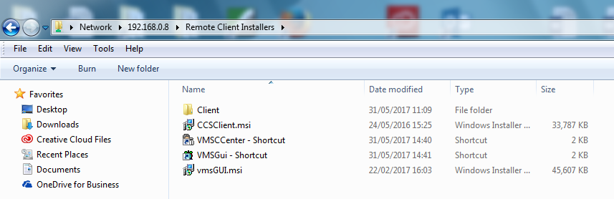

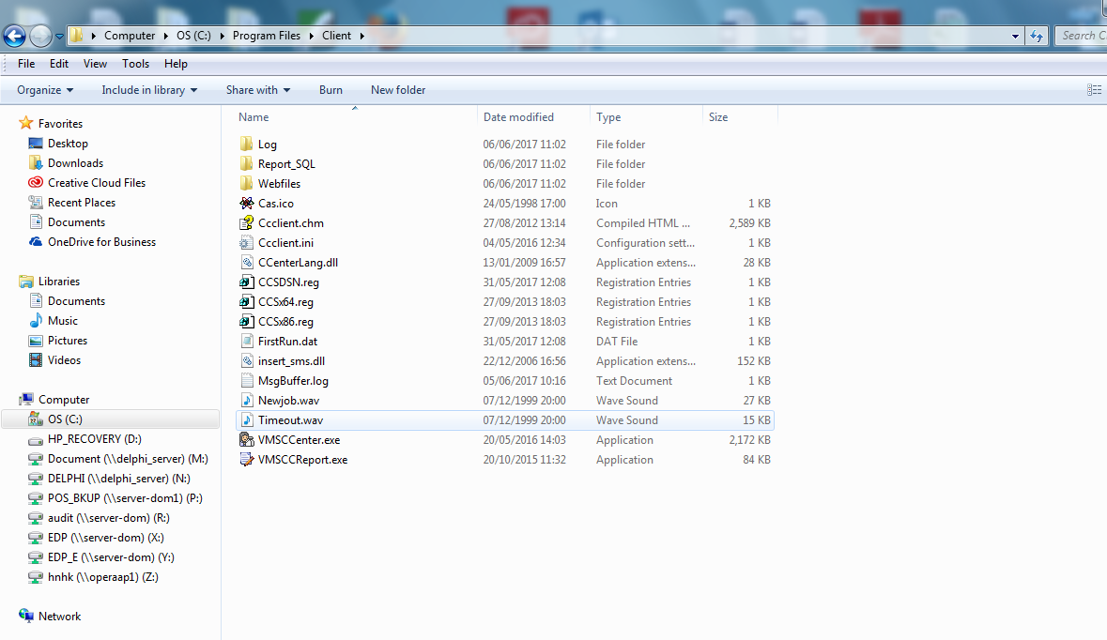

After finished the installation. Right-click “C:\Program Files(x86)\Client\VMSCCenter.exe”,run as administrator, and then setup the CCS Server IP & CCS Server DNS as below for the first time.
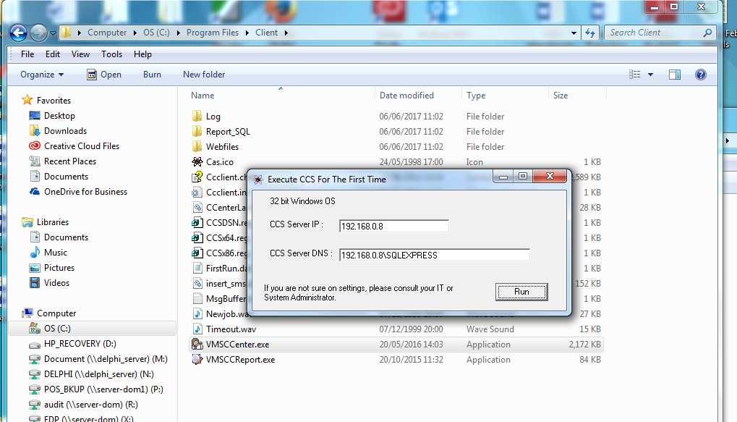
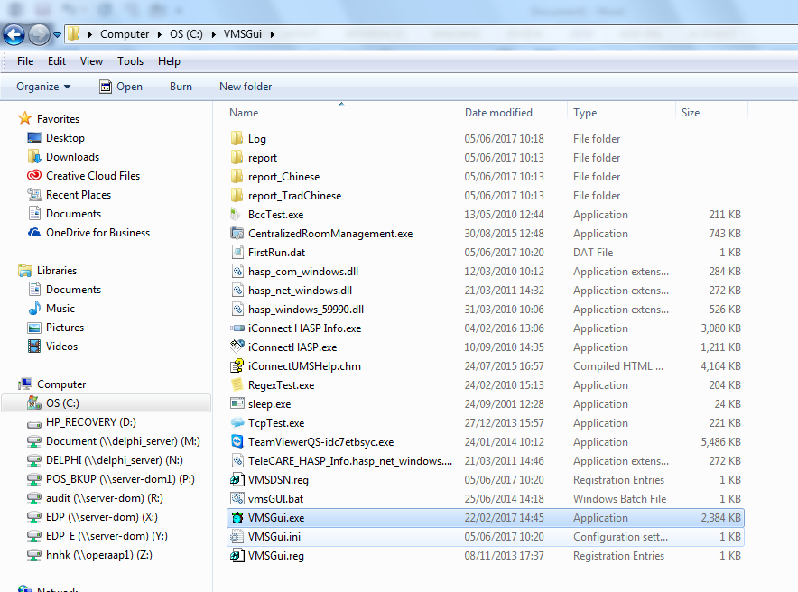

Input 192.168.0.8
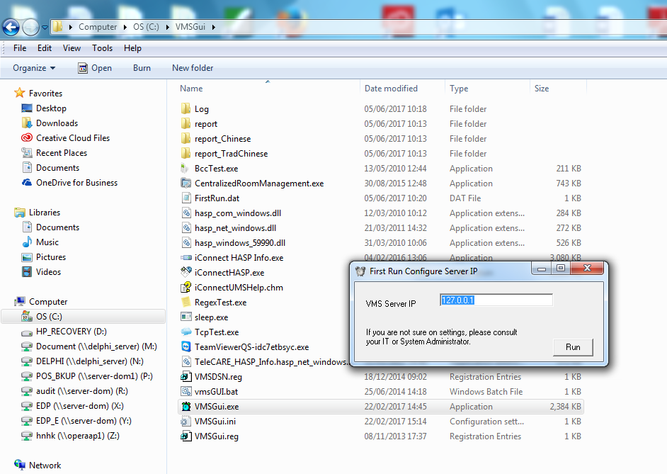
** If want to reset the ip address configured, Delete FirstRun.dat file

Copy below shortcut to user’s PC desktop
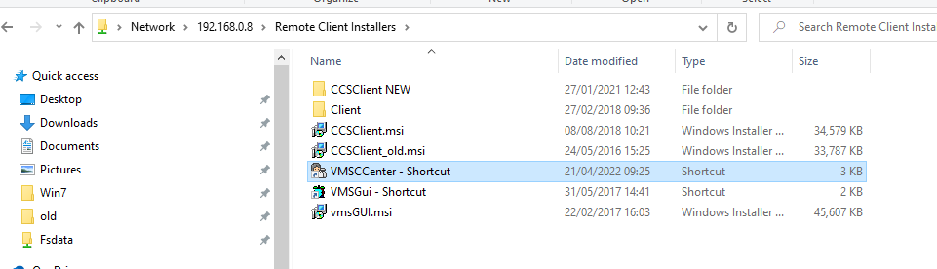

Android App
http://61.244.77.138:9001/app/

