For user change password by themselves
http://192.168.0.8:9001/change_password.php
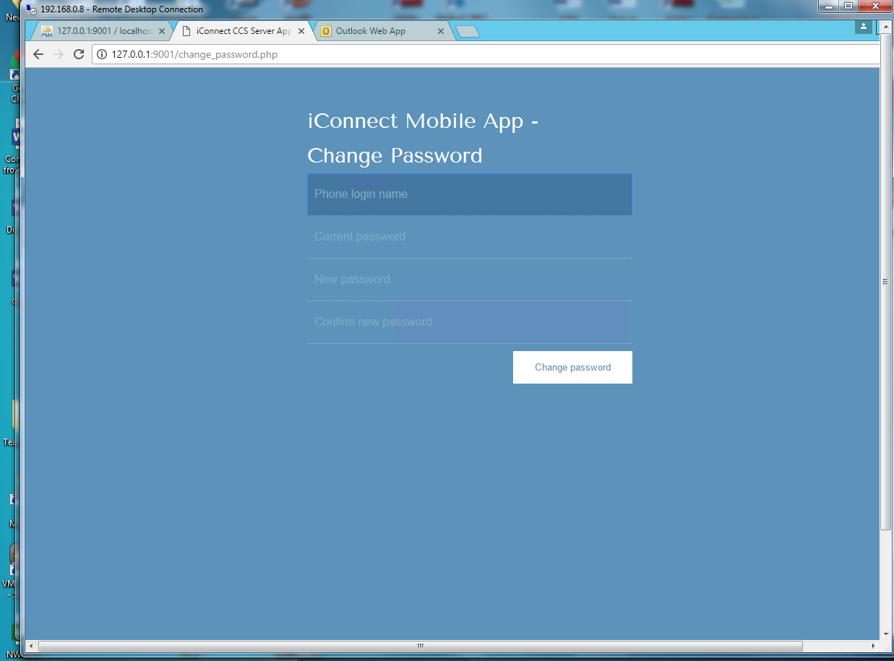
Manage mobile user login password, access right for RM Status and Mini Bar
http://192.168.0.8:9001/appadmin/

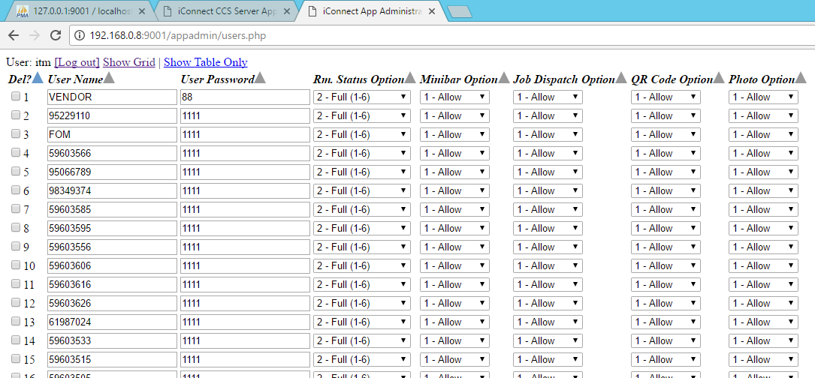

Desktop client
