RESTAURANT POS Switch
Tao Li
Netgear ProSafe 24 port 1000mbps smart switch 15 free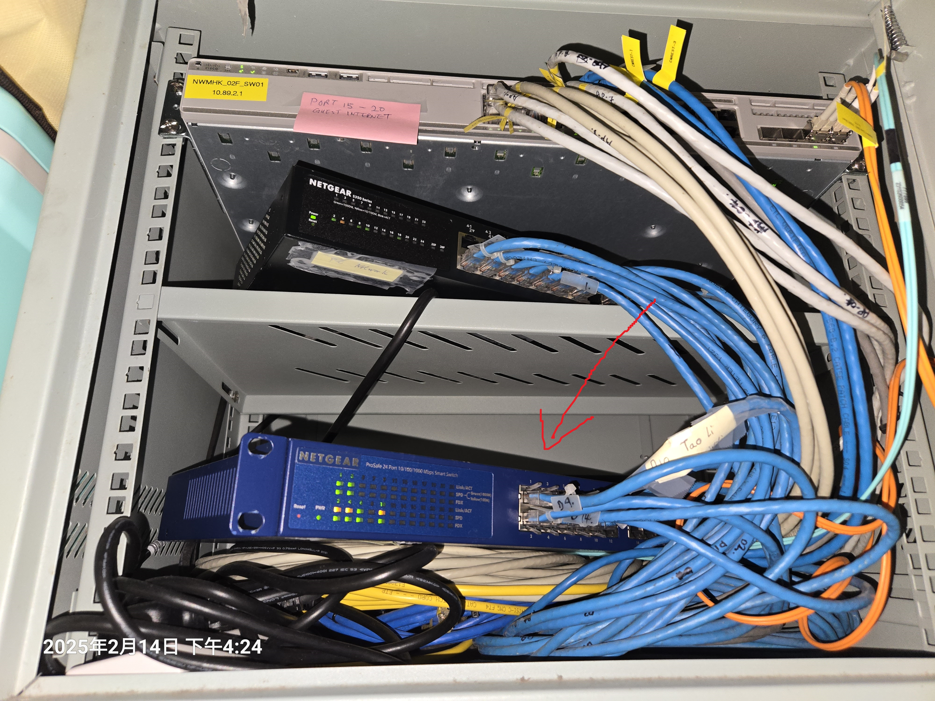
LaTabe
Netgear ProSafe 24 port 1000mbps smart switch 13 free
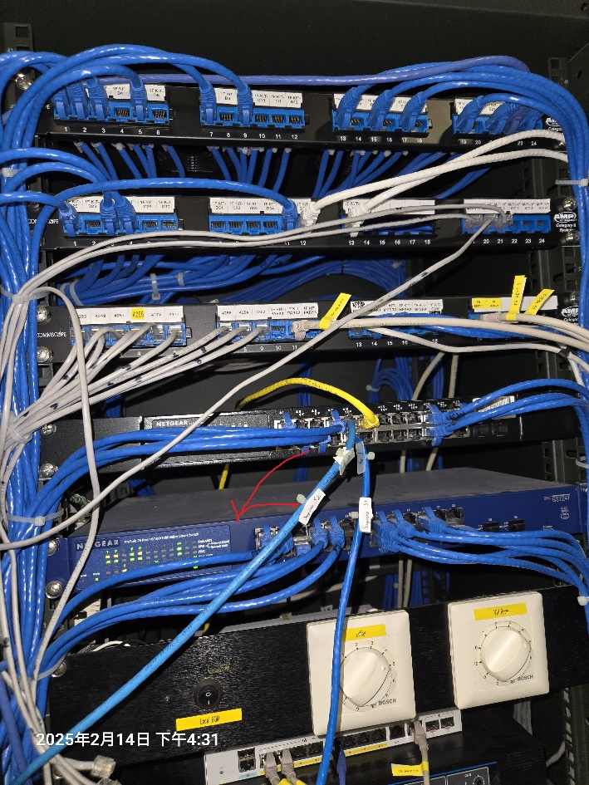

15F Residence Lounge & Bar
level one Ges-2450 24 port 19 free
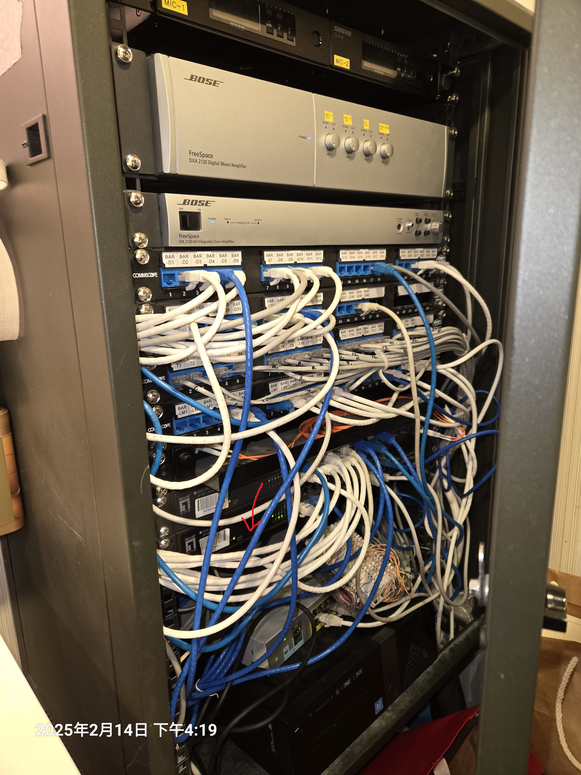
The Lounge 202.0.0.104
cisco catalyst 2960-L Series 8 port 5 free
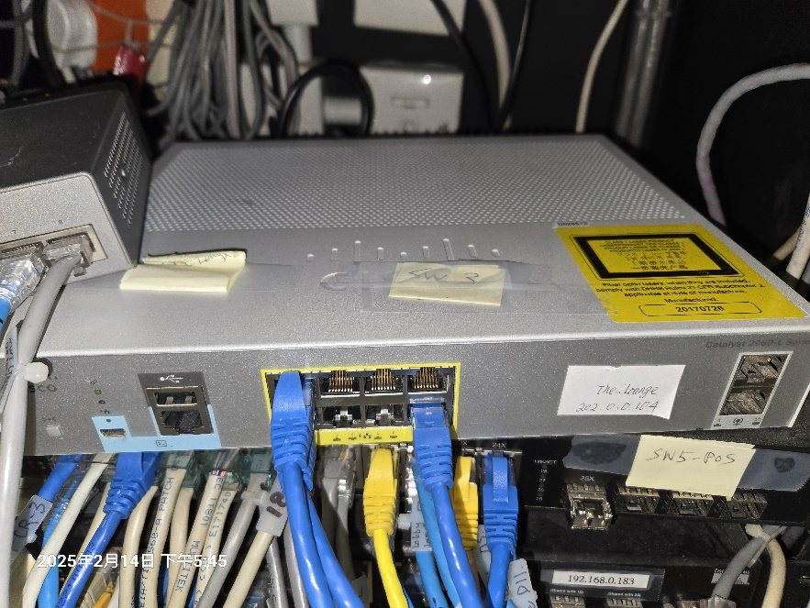
CAFÉ EAST 202.0.0.100
level one SWITCH
